STA2023 – Statistical Methods I
Instructor: Dr. Emil Agbemade
Chapter 7. Sampling Distributions
Table of Contents
7.1 Distribution of the Sample Mean 2
Sampling from a Normal Population Error! Bookmark not defined.
Sampling from a Nonnormal Population 5
7.2 Distribution of the Sample Proportion 7

Learning Objectives:
By the end of this chapter, students should be able to:
- Describe the sampling distribution of the sample mean and use that distribution for probability calculations.
- Describe the sampling distribution of the sample proportion and use that distribution for probability calculations.

7.1 Distribution of the Sample Mean
- Suppose the US government wants to determine the mean income of all US households. They could survey every US household to determine μ, but that is extremely time-consuming and expensive.
- Instead, the US government could (and does) survey a random sample of US households and use those results to estimate the mean household income.
  - The Current Population Survey is administered to about 60,000 randomly selected households each month.
- For example, in 2021, the mean annual household income in the US was estimated to be $\overline{x}$ = $121,840. The government might infer that the mean of all US households in 2021 was μ = $121,840.
  - However, households are selected by chance (random sampling).
  - A second random sample had $\overline{x}$ = $122,293.
  - A third random sample had $\overline{x}$ = $120,939.
- Because households selected will very sample to sample, the sample mean of household income will also very sample to sample.
  - Since $\overline{x}$ is a numerical measure (that is the result of a random process), we can treat $\overline{x}$ as a random variable.
  - Since $\overline{x}$ is a random variable, it has its own distribution.
Definition: The sampling distribution of a statistic

Sampling from a Normal Population:
Definition: Suppose that a simple random sample of size n is drawn from a population with mean µ and standard deviation σ. If X is approximately normally distributed, then the sampling distribution of $\overline{x}$:

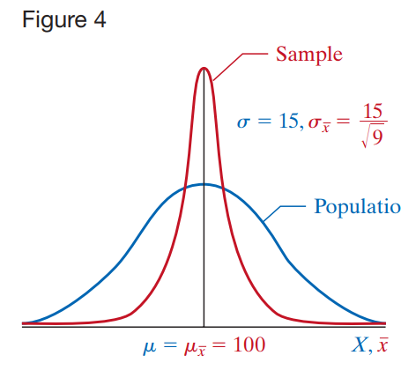

Example 1: We are sampling from a population with a mean of 25 and a standard deviation of 5. What is the mean and standard error of the sample mean when n = 2 and n = 30?

Example 2: The IQ, X, of humans is approximately normal with mean = 100 and standard deviation = 15. Compute the probability that a simple random sample of size n = 10 results in a sample mean greater than 110. That is, compute $P\left(\overline{X}>110\right).$

Compare this to the probability that we randomly select a single individual having over 110 points.

Example 3: The heights of human males in the US are about normally distributed with a mean = 69 inches and standard deviation = 3 inches. If we randomly sampled 9 US males, what is the probability that their sample mean would be below 66 inches?

Sampling from a Nonnormal Population
Example 4:
When the Population Is Uniform
- Suppose we take random samples from a uniform distribution (where all values within a range are equally likely).

- For small sample sizes (n = 2), the sampling distribution of the sample mean is not perfectly normal—it may appear triangular or uneven.

- As the sample size increases (e.g., n = 30), the distribution of the sample means becomes approximately bell-shaped

When the Population Is Skewed
- If the original population is strongly skewed (for example, skewed to the right):
  - For small samples (n = 2), the sampling distribution of the means remains skewed.

  - For moderate samples (n = 5), the shape becomes less skewed.

  - For larger samples (n = 30 or more), the distribution of the sample means becomes nearly bell-shaped (normal).

There are two key concepts to understand in the previous example.

Definition: The Central Limit Theorem ‘

- Based on the definition above, what sample size of n is “good enough” for the sample means to be normally distributed?
- Our rule of thumb is that if the distribution of the population is unknown or not normal, then the sample size should be at least 30, or n ≥ 30.

Example 5: The mean weight gain during pregnancy is 30 pounds, with a standard deviation of 12.9 pounds. Weight gain during pregnancy is skewed right. An obstetrician obtains a random sample of 35 underweight (body mass index less than 18.5) patients and determines that their mean weight gain during the pregnancy was 36.2 pounds. Does this result suggest anything unusual?

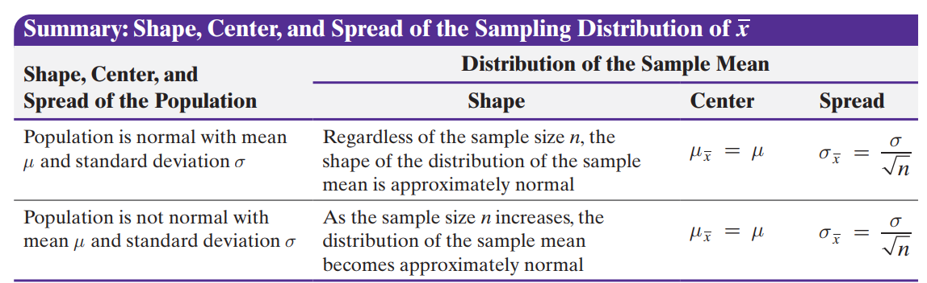

7.2 Distribution of the Sample Proportion
- In 7.1, we talked about the shape, center, and spread of the sampling distribution of the sample mean, $\overline{x}$.
- Now, we will talk about the sampling distribution of the sample proportion, the proportion of individuals in a sample who have a specified characteristic.
- Basic Notation:

Example 6: The Harris Poll conducted a survey of 1200 adult Americans who vacation during the summer and asked whether the individuals plan to work while on summer vacation. Of those surveyed, 552 indicated that they plan to work while on vacation. Find the sample proportion of individuals surveyed who plan to work while on summer vacation.

Sampling Distribution of a Sample Proportion ($\hat{p}$)

When we take a random sample and find the sample proportion ($\hat{p}$), the result can change from one sample to another.
This variation forms the sampling distribution of ($\hat{p}$).

What Happens as the Sample Size Increases
- For small samples, the values of $\hat{p}$ can vary a lot and the shape is uneven.

- For larger samples, the distribution of $\hat{p}$ ​ becomes smoother and starts to look bell-shaped.

- For very large samples, the distribution is almost perfectly normal (bell-shaped) and has less spread.

Definition: Sampling Distribution of $\hat{p}$:

Example 7: According to the National Center for Health Statistics, 15% of all Americans have hearing trouble.
(a) In a random sample of 120 Americans, what is the probability at most 12% have hearing trouble?
(b) Suppose that a random sample of 120 Americans who regularly listen to music
using headphones results in 26 having hearing trouble. What might you conclude?

